MUNICIPAL LAND FOR SALE
121 POOLE STREET, VILLAGE OF TORQUAY, SK
Land Description: Lot 15 Block 11 Plan ER6632
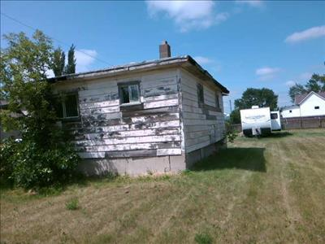
ASSESSED VALUE $12,900
Area of Land 5750 SQ FT
Estimated Property Tax Land Only $800.00
Area of Building 520 SQ FT
Estimated Property Tax with Current Building $1200.00
Tender forms are available at the Village office or home page of the website www.villageoftorquay.com
For more information 306-421-6123
An RV located on the property is excluded from this sale. The purchaser will acquire no ownership interest in the RV through the purchase of the property. Upon completion of the sale, the purchaser will be responsible for making lawful arrangements for the RV’s continued storage or removal. Any purchase of the RV must be negotiated separately with its owner and is subject to a registered lien. The property sale does not discharge that lien, the Village of Torquay does not authorize the purchaser to sell, scrap or otherwise dispose of the RV.

TENDER TO PURCHASE MUNICIPAL BUILDING
Property: 121 Poole Street, Torquay, SK
Name: __________________________ Address: ________________________ Postal Code: __________
Phone: _________________________ Email: _________________
Tender Amount
I hereby submit a tender to purchase the above-noted property for: $ ___________________

TERMS & CONDITIONS
- Tenders must be submitted in a sealed envelope marked “Municipal Building Tender –121 Poole Street” and delivered to the Village of Torquay, Box 6, Torquay, SK S0C 2L0, no later than 3:00 PM, November 12, 2026. Late tenders will not be accepted.
- The highest or any tender not necessarily accepted. The Village reserves the right to reject any or all tenders and accept the tender deemed in the best interest of the municipality.
- The successful bidder will be required to enter into a formal Agreement for Sale. Possession date to be agreed upon.
- The purchaser is responsible for all legal fees, title transfer costs, adjustments, and inspections.
- The property is sold “as is, where is”, with no representations or warranties, including but not limited to condition (structural or environmental), zoning, or permitted uses. The purchaser acknowledges they have conducted their own due diligence.
- The purchaser agrees to indemnify and save harmless the Village of Torquay, its council members, employees, and agents from any claims or liabilities arising from the condition of the property.

SUBMISSION
I hereby submit this tender subject to the above terms and conditions.
Signature: ______________________________________ Date: ____________________________

