MUNICIPAL PROPERTY FOR SALE
118 DEVON STREET, VILLAGE OF TORQUAY, SK
Land Description: Lots 27-28 Block 2 Plan AY3091
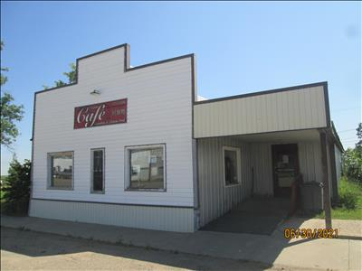
Built in 1989
Area of Main Building 1450 SQ FT
Area of Land 5750 SQ FT
2026 SAMA Assessed value $48,100
Property Tax approximately $1583.09
Tender forms are available at the Village office or home page of the website www.villageoftorquay.com
For more information 306-421-6123
TENDER TO PURCHASE MUNICIPAL BUILDING
Property: 118 Devon Street, Torquay, SK
Name: __________________________ Address: ________________________ Postal Code: __________
Phone: _________________________ Email: _________________
Tender Amount
I hereby submit a tender to purchase the above-noted property for: $ ___________________

TERMS & CONDITIONS
- Tenders must be submitted in a sealed envelope marked “Municipal Building Tender – 118 Devon Street” and delivered to the Village of Torquay, Box 6, Torquay, SK S0C 2L0, no later than 3:00 PM, July 8, 2026. Late tenders will not be accepted.
- The highest or any tender not necessarily accepted. The Village reserves the right to reject any or all tenders and accept the tender deemed in the best interest of the municipality.
- The successful bidder will be required to enter into a formal Agreement for Sale. Possession date to be agreed upon.
- The purchaser is responsible for all legal fees, title transfer costs, adjustments, and inspections.
- The property is sold “as is, where is”, with no representations or warranties, including but not limited to condition (structural or environmental), zoning, or permitted uses. The purchaser acknowledges they have conducted their own due diligence.
- The purchaser agrees to indemnify and save harmless the Village of Torquay, its council members, employees, and agents from any claims or liabilities arising from the condition of the property.

SUBMISSION
I hereby submit this tender subject to the above terms and conditions.
Signature: ______________________________________ Date: ____________________________

